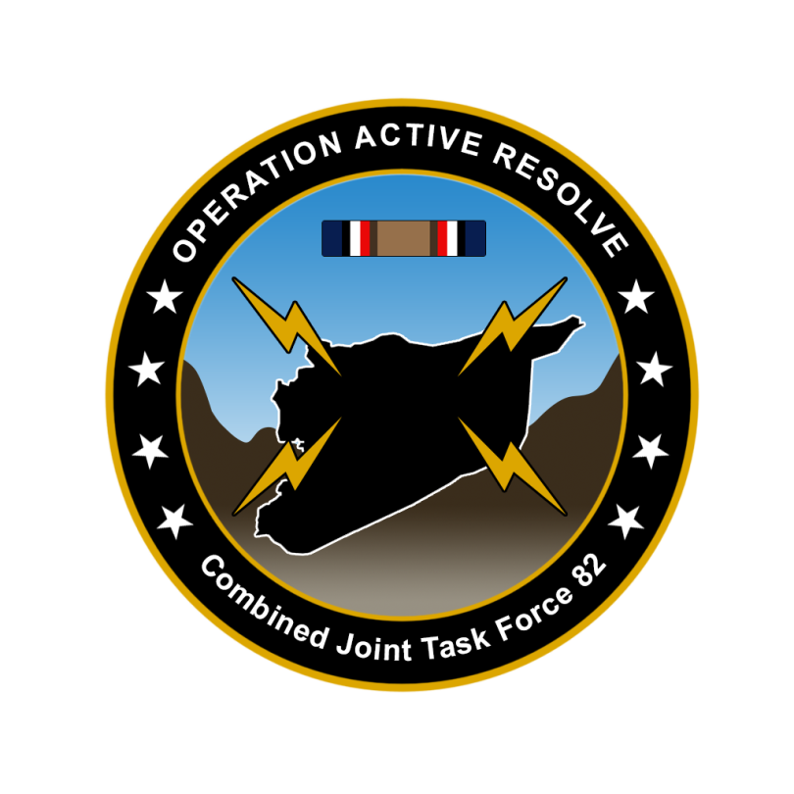

CJTF-82 OPERATION ORDER

OPERATION ACTIVE RESOLVE

# SITUATION

## General situation

July 1st, 2011, Syria conducted a surprise attack against Turkey. After a week of intense fighting the Syrian forces in Turkey have seized control of the area of Birecik Dam. 10th of July, UN Security Council released resolution 3263 which calls the Syrian aggression unlawful, and those Syrian forces should be returned to its position before 1st of July 2011. 15th of July, a coalition of the willing is formed to support Turkey. The military coalition have been given the name Combined Joint Task Force 82.

1st of August, UN Security Council resolution 3274 was released. This resolution gave Syria a deadline of 31st of August 2011 to comply with UNSCR 3263, and the resolution empowers states to use all necessary means to force Syria out of Turkey after the deadline.

## Friendly situation

### Land Component Command (LCC)

Land Component Command consists of one US Led Corps: IV Corps consisting of 55th Mechanized Division and 56th Armored Division.

### Maritime Component Command (MCC)

Maritime Component Command consist of

* Carrier Strike Group-72 (CSG-72): USS Abraham Lincoln + 1x Arleigh Burke
* Surface Action Group 1 (SAG-1): 1x Oliver Hazzard Perry + 1x Ticondoroga

### Joint Force Air Component Command (JFACC)

Joint Force Air Component Command consists of the 132nd Virtual Wing and external organizations participating. Air bases available are Incirlick Airbase in Turkey and RAS Akrotiri and RAF Kingsfield in Cyprus. E-3 (3x E-3) and Tanker squadrons (4x KC-135 and 4x KC-135 MPRS) are arriving in theater and are getting ready to support operations (locations for the various squadrons will be based on JFACC planning). In addition to all the aircraft, a Patriot Battalion with two Patriot Batteries are also attached to JFACC.

### Special Operations Component Command (SOCC)

Special Operations Component Command consists of 4 Special Operations Task Groups based both in Israel and Turkey.

## Enemy situation.

### Syrian Army

* Syrian 1st Corps have seized the Birecik Dam and Gazientep International Airport and are in defensive positions to defend Syria’s newly seized area of Birecik and Gaziantep International airport. 1st Corps is HQ is likely located IVO Minakh Airbase together with the 10th Armored Division acting as a reserve for both 1st and 2nd Corps. 12th Motorized Division is occupying the Birecik Dam while the 11th Mechanized Division is occupying Gaziantep International Airport.
* Syrian 2nd Corps have occupied the border region north of its bases and is likely preparing an offensive into Turkey to seize control of Hatay Airport in order to prevent the base being used as a staging base for logistics and for RW operations into Syria. 2nd Corps HQ likely located IVO Taftanaz Airbase.
* Syrian 3rd Corps are established in defensive positions south and west of Damascus.
* Syrian 4th Corps are conducting rear duty assignments and protecting Damascus.
* Syrian 5th Corps are in their base in Palmyra, finishing their workup to be prepared for operations.

### Syrian Air Force

Syrian aircrafts have been conducting CAP missions to protect the Army from airstrikes from Israel and Turkey. Syrian aircraft have also supported the Army’s offensive by conducting strikes on critical targets in Turkey and Israel.

### Syrian Naval Forces

1st Patrol Boat Squadron, based in Latakia, with 5xFSG 1241.1MP Molniya and 2nd Frigatre Squadron based in Tartus with 3x Frigate 1135M Rezky. Both squadrons are likely tasked with preventing supplies or military vessels to interfere between Cyprus/Turkey and Syria.

### Enemy Most Likely Course of Action (ML COA)

Syrian forces will likely strengthen their current position and establish defensive positions to withstand a attack from the coalition. A coalition ground attack at the Syrian 1st Corp positions in Turkey will likely trigger a counterattack from the 10th Armor Division. Any sign of coalition ground attacks will likely trigger heavy artillery and MLRS attacks against coalition forces. Syrian SAM units is likely on high alert, and Syrian Air Force is likely to establish CAP close to the border to prevent interference from coalition aircraft.

### Enemy Most Dangerous Course of Action (MD COA)

Syrian 5th Corps will start moving NORTH and take part in an offensive to further expand the Syrian territory in Turkey. 10th Armor division will start an attack to the WEST to seize Hatay airfield. Syrian Air Force conducting strikes in Turkish territory, primarily aimed at Turkish airfield to prevent coalition use of the airbases. If threatened Syrian Regime may threaten to use, or actually use chemical weapons against Turkey and coalition forces.

# MISSION

CJTF-82 will deploy to the area of operations (AO) and restore Turkish territorial integrity, once sufficient forces is available CJTF-82 will neutralize Syrian offensive capability in order to (IOT) contribute to a secure and stable environment, which will facilitate a lasting peace and render future international military presence unnecessary.

# EXECUTION

## Commander CJTF-82 intent.

### Purpose.

The purpose of this operation is to support Turkey in defeating the Syrian aggression.

### Endstate.

Syrian will and ability to conduct offensive operations in the region neutralized. Turkish territorial integrity restored. International freedom of movement in the region restored.

## CONCEPT OF OPERATIONS

Operation Active Resolve will be conducted in 3 phases:

Phase 1: Shaping

Phase 2: Decisive action

Phase 3: Stabilization

### Phase 1: Shaping

Deploy forces to the region, building situational awareness (SA) of the situation and defend Turkey against Syrian aggression.

Set conditions for CJTF land offensive into Syrian to destroy Syrian offensive capability.

Phase ends when Syrian forces in Turkey have been defeated and Turkey territorial integrity have been restored.

In this phase JFACC will be the supported commander.

### Phase 2: Decisive action

Attack Syrian forces within Syria in order to neutralize Syrian offensive capability

In this phase LCC will be the supported commander.

### Phase 3: Stabilization

Once Syrian offensive capability is neutralized, focus will shift to stabilize the situation and prepare for transition back to a situation where all actors respect the recognized international borders.

In this phase LCC will be the supported commander.

## OBJECTIVES

CJTF-82 has the following objectives:

1. Establish air superiority over Turkey.
2. Defeat Syrian forces in Turkey.
3. Destroy Syrian WMD (weapons of mass destruction) capability.
4. Establish air superiority over Syria.
5. Neutralize Syrian Army offensive capability.
6. Reduce Syrian will to conduct offensive operations in the region.
7. Reduce influence from terror groups in the region.
8. Reduce influence from insurgent groups in the region.

## TASKS:

### Land Component Command (LCC):

COM LCC will:

* Build up forces
* Defeat Syrian forces in Turkey.
* On order (O/O) conduct ground offensive into Syria in order to neutralize Syrian capability to conduct offensive operations.

### Maritime Component Command (MCC):

COM MCC will:

* Maintain sea control outside Turkey, Cyprus and Syria in order to prevent any interference in CJTF-82 operations.
* Secure SLOC (Sea Lines Of Communication) into Turkey and Cyprus.

### Joint Force Air Component Command (JFACC):

COM JFACC will:

* Establish and maintain air superiority over Turkey.
* Establish and maintain air superiority over Syria for phase 2.
* Set conditions for LCC ground offensive into Syria in phase 2.
* Plan, organize and execute targeting on behalf of CJTF-82.
  + Conduct AI campaign to break the Syrian will and capability to conduct offensive operations.
* Support CJTF-82 with air support as requested throughout the operation.

### Special Operations Component Command (SOCC):

COM SOCC will conduct full spectrum special operations in order to :

* Support for CJTF-82 targeting in all phases
* Support counterinsurgency (COIN) operations
* Support for counterterrorism (CT) operations

# ADMINISTRATION AND LOGISTICS

Resupplies will primary be shipped in via sea lines of communication (SLOC). Priority resupplies may be flown into Turkey or Cyprus.

Due to other major military operations taking place at the same time, certain high demand ammunition items may be temporarily unavailable.

# COMMAND AND CONTROL

CJTF-82 HQ located at Incirlik Airbase, Turkey.